**Coding Outputs**

**Graphical Outputs:-**

1.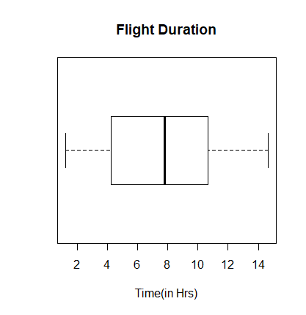

2. 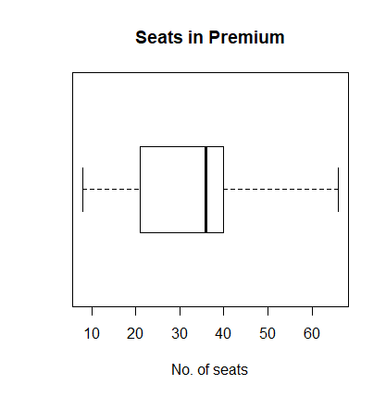

3. 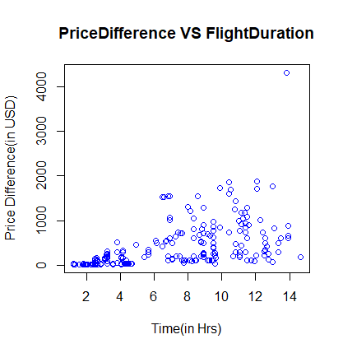

3

4. 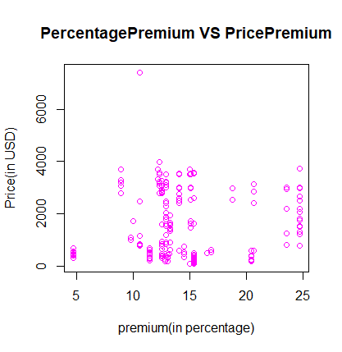

5. 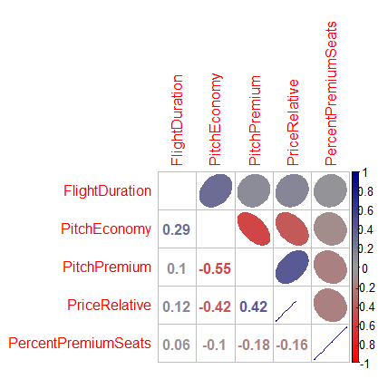

**Regression Model Output:-**

RelativePrice = 0.037*(FlightDuration)-0.366*(PitchEconomy)-0.022*(PrecentPremiumSeats) +11.969

Residuals:

Min 1Q Median 3Q Max

-0.84447 -0.27098 -0.09805 0.21059 1.36285

Coefficients:

Estimate Std. Error t value Pr(>|t|)

(Intercept) **11.963876** 0.887327 13.483 **< 2e-16** ***

FlightDuration **0.037114** 0.005255 7.062 **6.18e-12** ***

PitchEconomy **-0.366420** 0.028510 -12.852 **< 2e-16** ***

PercentPremiumSeats **-0.021773** 0.003694 -5.894 **7.35e-09** ***

---

Signif. codes: 0 ‘***’ 0.001 ‘**’ 0.01 ‘*’ 0.05 ‘.’ 0.1 ‘ ’ 1

Residual standard error: 0.3786 on 454 degrees of freedom

Multiple R-squared: **0.2985**, Adjusted R-squared: **0.2939**

F-statistic: 64.4 on 3 and 454 DF, **p-value: < 2.2e-16**